Pressemitteilung ifm-pm 868/0626 Area: company news

ifm reorganises software business with supply chain focus – GIB to regain independence
Essen / Siegen, June 2026. The ifm group of companies is reorganising its software business: The activities with a focus on the supply chain that were previously managed by ifm business solutions gmbh and GIB S & D GmbH will be separated from the group structure and, in future, bundled again independently under the established GIB brand. ifm will remain the sole owner of GIB and will continue to support the company’s further development closely and in partnership as a financial investor. The market launch is planned for early October this year.
The reorganisation aims to enable the supply chain management business to develop more efficiently, rapidly and with greater potential outside ifm’s core business. In future, GIB will clearly position itself as a software company for intelligent supply chain solutions in the SAP environment. Customers and market partners were informed about the upcoming changes at the “ifm Success Days” on 9 and 10 June in Siegen, a well-established conference for supply chain experts.
“We are convinced that GIB can realise its full potential even more effectively in this structure. That is why we have decided to establish the business as an independent entity going forward. The return of the GIB brand – which is well known and highly regarded among decision-makers in supply chain management – sends a strong signal to customers and the market,” says Michael Marhofer, Executive Director of the ifm group of companies. “We believe in the business model, the strong customer base and the market potential – and we are confident that the newly formed GIB will continue to be a great success.”
The “new” GIB will combine development, consulting, support and sales within a single organisation. The aim is to streamline decision-making, create closer alignment between functions, accelerate innovation cycles and support customers even more directly and efficiently.
“Many customers have known us as GIB for three decades. This is exactly what we are now building on – with the same DNA, but new momentum and a clear focus. The new structure gives us the entrepreneurial flexibility to support our customers even faster, more directly and with measurable added value,” says Björn Dunkel, CEO of ifm business solutions gmbh and designated CEO of GIB. “We consistently focus on what really matters to our customers: real supply chain essentials. We are pleased that ifm is enabling this approach while remaining a strong and reliable shareholder,” Dunkel adds.
The organisational restructuring will be implemented step by step until the official market launch in October, with ifm providing close support throughout the process. At the same time, GIB continues to systematically advance the development of its solutions and services. Customers benefit from faster decisions, more direct communication and accelerated innovation cycles – while contacts, contracts and services remain unchanged.

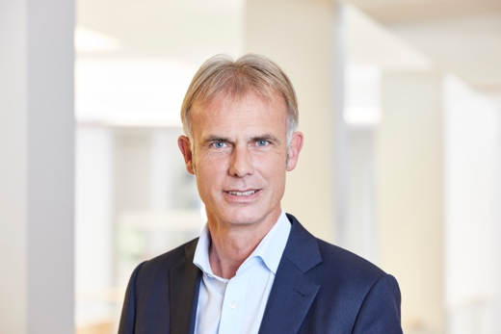 | ifm-pm 868 print_1.jpg  Michael Marhofer, Executive Director of the ifm group of companies
 | ifm-pm 868 print_2.jpg  Björn Dunkel, CEO of ifm business solutions

About the ifm group of companies
From a passion, to an idea, to success. Since its foundation in 1969, ifm has developed, produced and sold sensors, controllers, software and systems for industrial automation and for SAP-based solutions for supply chain management and shop floor integration worldwide. As one of the pioneers of Industry 4.0, ifm develops and implements consistent solutions to digitalise the entire value chain “from sensor to ERP”. Today, the second-generation family-run ifm group has more than 9,120 employees, including more than 5,260 in Germany, and is one of the worldwide market leaders. The group combines the internationality and innovative strength of a growing group of companies with the flexibility and close customer contact of a medium-sized company.

About GIB
For more than 30 years, GIB has been synonymous with intelligent supply chain solutions in the SAP environment. Founded and headquartered in Siegen, the company has been an SAP partner since 1998 and holds, among other things, certifications for SAP S/4HANA Cloud and Clean Core. In 2016, GIB became part of the ifm group of companies and was gradually integrated into the group structures. Software development and consulting currently operate under ifm business solutions gmbh, while sales activities for supply chain software solutions are bundled within G.I.B. Sales & Development GmbH. Today, more than 1,000 customers worldwide use GIB solutions across more than 2,000 SAP systems. In addition to its core markets of Germany, Austria and Switzerland (DACH) and Italy, the company also intends to further expand its business in the USA in particular. GIB currently employs around 150 people.

Printing free of charge – reference copy requested.

Editorial enquiries  Agentur Dr. Lantzsch  Jörg Lantzsch  Müllerstr. 5  65183 Wiesbaden  www.drlantzsch.de  Tel.: +49 611 205 93 71  Email: info@drlantzsch.de | Contact  ifm electronic gmbh  Simone Felderhoff  Friedrichstr. 1  45128 Essen  www.ifm.com  Tel.: +49 201 24 22 0  Fax: +49 201 24 22 1200  Email: presse@ifm.com

